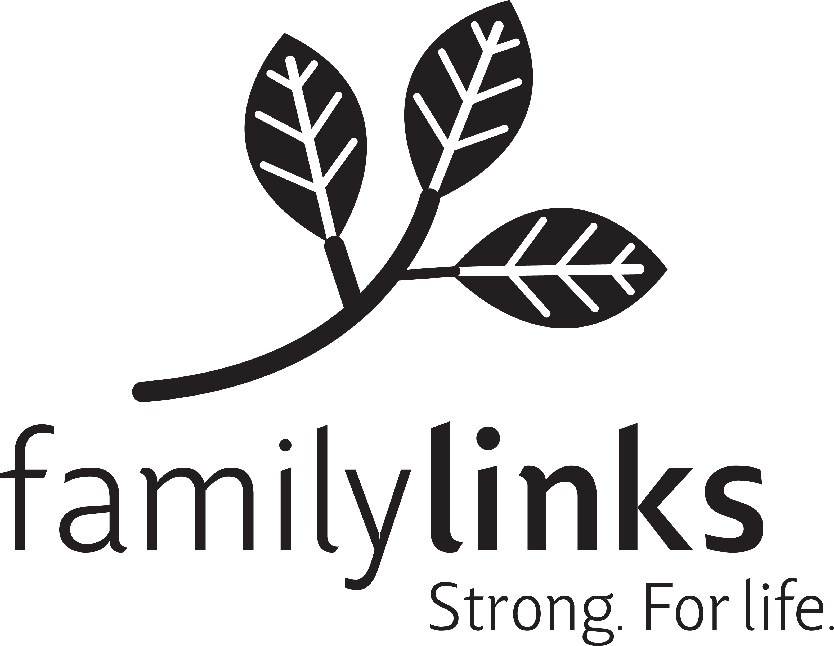
Familylinks Training Institute
August / November 2026
Trainings

Managing Time Effectively (Webinar)
August 25,2026
9:30 – 12:30
John Amato
$75 – (includes LSW credits)

Discover new ways to manage yourself—and your time—in order to significantly reduce stress and feelings of being out of control. In today’s busy world, it’s easy to feel as if there are never enough hours in the day to complete tasks. Although time is not adaptable, human behavior can be changed. This session provides the tools needed to organize and simplify workloads.

Ethical Considerations for Home Visitors (Webinar)
September 22, 2026
9:30 – 12:30
Erin Troup
$75 – (includes LSW credits)

This presentation focuses on looking at the boundaries, Ethics and dual relationships that occur withing home visiting and community support programs. Often the deep relationships that are formed with home visiting work tend to have folks in a bind and finding themselves within a lot of challenges that can become problems if not addressed adequately. Real‐ life in the field examples and discussion is infused into this 3‐hour training to help professionals “stay in their lane” and still feel effective in providing great care.

Autism & The Brain (Webinar)
October 6, 2026
9:30 – 12:30
Pa􀆩y Maxwell
$75 – (includes LSW credits)

There is no “one size fits all” when it comes to Autism. This training will support educators and families to better understand the many types of services and interventions available for children diagnosed on
the Autism Spectrum. We will dive into specific examples with discussions and support what best suits kids of all developmental levels and ages. Participants will gain a better understanding of the many faces of autism and take a closer look into numerous options available for treatments with educational and home‐based services.

Familylinks Training Institute
August / November 2026
Trainings (2)

Trauma Informed Care (LIVE – 401 N. Highland Avenue, 15206)
October 14, 2026
9:30 – 4:30
Alissa Klugh
$150 – (includes LSW credits)

Enhance your knowledge and ability to understand, empathize, and support how your clients’ history can impact their daily functioning with trauma‐informed treatment. Learn more about trauma‐informed care, an inclusive approach that allows clients (and the clinician) to discover the effects that their lives’ events and perceptions of those events on daily mood, interactions, assumptions, thoughts, feelings, and behaviors. Based on principles of evidence‐based practices that come together to formulate an overall understanding of trauma’s effects on the body and mind, it is designed to produce self-awareness, patterns of responding to stress, and psychoeducation, which can lead to a shift in thinking, feeling, and behaving. Instead of guiding clients with basic processing, trauma‐informed care works in conjunction with other treatment principles to get a handle on the underlying beliefs that drive our thinking, perceptions, and interpersonal relationships.

Women in Addiction and Recovery (Webinar)
November 13, 2026
9:30 – 12:30
Lori Abbott
$75 – (includes LSW credits)

Enhance your skills as a service provider for women confronting addiction and recovery. Discuss the myths and issues surrounding women and addiction and also discuss the specific needs of this population. Discover effective strategies for addressing those needs as we focus on barriers to treatment as well as the challenges women face in committing to recovery after treatment.

Excellence In Coaching (Webinar)
November 23, 2026
9:30 – 12:30
John Amato
$75 – (includes LSW credits)
Coaching today is often seen as more of a luxury due to increasing demands on staff and leaders. Coaching, however, is a critical skill in assuring excellence in staff performance. In this training, the value of building one-on-one relationships and managing a process that results in specific improved performance in targeted areas will be presented. The GROW model will be presented as a method for leaders to practice in order to successfully coach and develop their teams to work together toward a common purpose and goal.

Familylinks Training Institute
August / November 2026
Trainings (3)
"These programs are offered for 3 CE hours of social work continuing education through co-sponsorship of the University of Pittsburgh's School of Social Work, a Council on Social Work Education accredited school and therefore a PA pre-approved provider of social work continuing education. The Trauma Informed Care training offers 6 CE credits. These credit hours satisfy requirements for LSW/LCSW, LMFT, and LPC biennial license renewal. For information on social work continuing education please visit socialwork.pitt.edu/continuing-ed.”

Familylinks Training Institute:
About the Presenters

Lori Abbott, MA, LPC
Lori is a Licensed Professional Counselor (LPC). She is an Associate Program Implementation Specialist in the Program Evaluation and Research Unit (PERU) of the University of Pittsburgh’s School of Pharmacy. Within PERU, Ms. Abbott has worked across several programs providing technical assistance in establishing both SBIRT and Medication for Opioid Use Disorder (MOUD) in primary care and single county authority (SCA) settings. Additionally, Ms. Abbott has provided over 50 trainings to both PERU staff and stakeholders. Ms. Abbott has worked for over 25 years with children, adolescents, adults, and families experiencing both mental health and drug and alcohol issues. Ms. Abbott brings with her extensive history and expertise to both areas. Ms. Abbott has over 15 years of training experience with stakeholders and clinical staff. She has been able to utilize this expertise to provide clinical support to the PERU team and stakeholders.

John Amato, M.Ed.
John is a Senior Training Consultant at Familylinks. He has over 40 years of clinical, managerial, and training experience in social services. He is a certified trainer for the Pennsylvania Child Welfare Resource Center. Since 1994, John has delivered hundreds of workshops and has provided consultation and training in the areas of leadership and team development. John earned his master’s degree from the University of Pittsburgh in 1980. In February 2014, John became a Certified Situational Leadership Experience trainer. In October of 2015, he became a Predictive Index Analyst. In June of 2020 John earned his certification as a Modern Classroom Certified Virtual Trainer (MCCT).

Patty Maxwell, M.Ed., M.S., BS
Patty is a licensed Behavior Specialist (BSL) with over 20 years of experience working throughout the mental health field in various positions including wraparound, intensive case management, family based mental health services and Early Intervention. She is the owner of Engage Kidz LLC and currently supports children and families virtually, in-home, school and in communities. Patty also supports teachers and professionals by coaching them through tough behavioral challenges and offers small and large group trainings. Her various educational backgrounds and experiences have allowed her to work with a wide range of ages (birth through adulthood) and support an array of learning abilities including individuals with autism, learning disabilities, behavioral challenges, intellectual disabilities and emotional disorders.

Alissa Klugh, MS, LPC, CTMH, CCTP-II, CIMHP, EMDRIA Approved Certified EMDR Therapist Alissa Klugh is a Licensed Professional Counselor (LPC). She owns and sees clients at Pittsburgh Psychotherapy Associates, LLC, in the North Hills of Pittsburgh. As an alumnus of the University of Pittsburgh, she obtained her master’s degree in Rehabilitation Counseling and a bachelor’s degree in psychology with a minor in Biology. She is Certified as an Integrative Mental Health Provider, Telemental Health Professional, and Clinical Trauma Professional. Alissa recognizes the connection between the mind and body and uses this in practice. She is a Beachbody coach and Reiki Master (Level III). With over 16 years of experience in the mental health field, Alissa has worked with children, adolescents, adults, families, and couples on their growth and change. She has worked with individuals struggling with depression, anxiety, trauma, mood disorders, anger management, self-improvement, co-parenting after separation/divorce, working through major life stressors, and building self-esteem by helping them find a new path. Alissa has taken her many years of working in direct care, private practice, and managing a mental health program for individuals with severe mental health needs and applied it to her skill set to bring information-seekers a better understanding of trauma, vicarious trauma, and healing in practice.

Erin Troup, LPC, NCC, CT, IMH-E (IV Clinical)
Erin is a Licensed Professional Counselor and the owner of Sprout Center for Emotional Growth and Development, LLC a private practice in Pittsburgh, PA specializing in early childhood social emotional needs, particularly attachment, grief & loss, trauma and anxiety. Erin earned her undergraduate degree in psychology and child development from Indiana University of Pennsylvania. She attended Chatham University for her MS in counseling and earned her Infant Mental Health Certificate in Pennsylvania’s first Infant Mental Health cohort. Erin has worked in the fields of Mental Health, Early Intervention and Behavioral Health service for over 15 years. She has presented on a variety of topics including mental health, grief and loss, social emotional and child development throughout the United States; but she calls Pittsburgh Pennsylvania home. She is the board secretary for The Pennsylvania Association for Infant Mental Health and a member of The Association for Death Education and Counseling. Erin also provides clinical and Reflective supervision for individuals seeking Licensure and Infant Mental Health Endorsement.



Registration Directions
Familylinks Training Institute is now using a new platform for registration and payment for our training offerings. To review the trainings and register:

- Go to https://familylinks.org/services/training-institute

- Click on the Familylinks | Kindful link.

- On the left side of the screen, you can see information about our training offerings
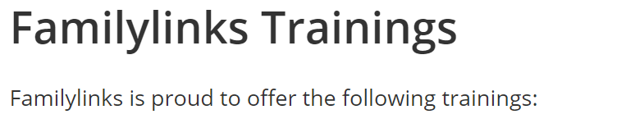

- Once you decide which training(s) you would like to register for, click on the PAY button
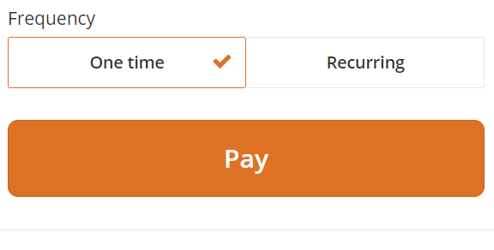

- IGNORE the “Would you like to add an additional $0.00 to cover transaction fees?” Do not check this box.

- On the left, scroll down the drop-down menu and select the training you would like to register for.



- Complete the information/payment section on the right side of the page.


NOTE: If you want to register for more than one training course, repeat the directions from step #2.

You will receive a receipt directly in your email.

If you have any questions, please reach out to training@familylinks.org.

